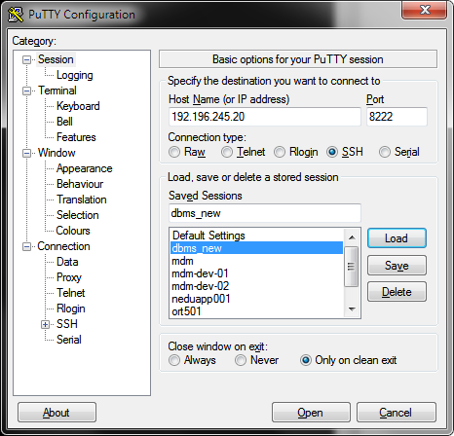

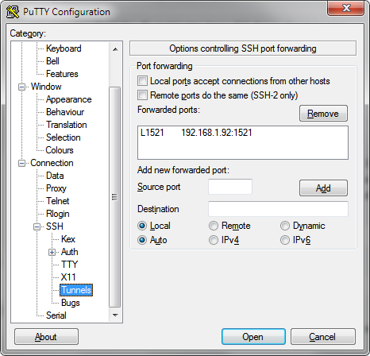

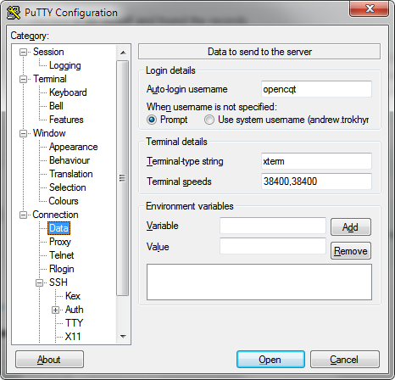

its forward port-forwarding

- local port through ssh tunnel goes to 192.168.1.92:1521 where db server runs.

So in your jdbc url you are connecting to localhost:1521

of course - make sure port is free on your pc or set it up different port in case if you have your local oracle server

and here is corresponding tnsnames record

ORT501N_L=

(DESCRIPTION=

(ADDRESS=

(PROTOCOL=TCP)

(HOST=localhost)

(PORT=1521)

)

(CONNECT_DATA=

(SERVICE_NAME=ort501)

)

)

unix login the same as for db -

user/pw: opencqt/opencqt123